HSCA of WNY
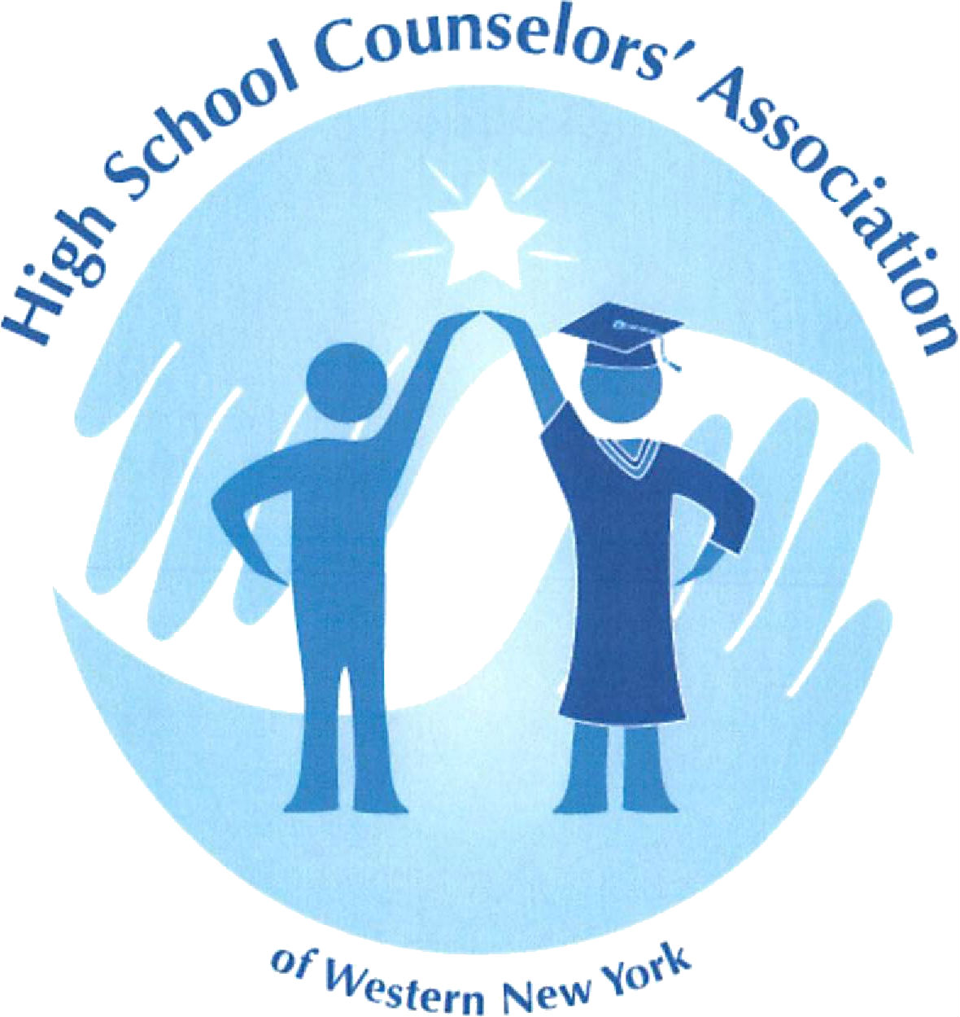
January Meeting
Friday, January 19, 2018
Daemen College
4380 Main Street
Amherst, NY 14226
Wick Student Center
First Floor Alumni Lounge

*Turn into Daemen from Main Street, at first stop sign make a right into the lot and park between Wick and Duns Scotus Building.

Program Agenda:

8:30-9:00 a.m. Networking, Sign-in, and beverages/continental breakfast

9:00-9:45 a.m Jack Armstrong – Announcer for the Toronto Raptors “Making an Impact” Presentation
*Gain some positive inspiration and recharge the batteries for an energizing start to 2018!

10:00-10:30 a.m Jessica Clark, Senior Associate Director of Admissions at University at Buffalo presenting on the Coalition Application

10:30 -Frank Williams, VP for Enrollment Management at Daemen
-Harry Gong & Dave Coates: National College Fair updates
-Jodie Cormier, announcements & organization business

Coordinated by:
Mark Veronica – Canisius HS & Terri Jacobs – Williamsville South HS

RSVP to Terri Jacobs – tjacobs@williamsvillek12.org (by January 16th)

